**Project Design Phase-II**

**Data Flow Diagram & User Stories**

| Date | 23 May 2023 |
| --- | --- |
| Team ID | NM2023TMID02006 |
| Project Name | Accessing the safety of municipal drinking  water |

**Data Flow Diagrams:**

A Data Flow Diagram (DFD) is a traditional visual representation of the information flows within a system. A neat and clear DFD can depict the right amount of the system requirement graphically. It shows how data enters and leaves the system, what changes the information, and where data is stored.



**Example:** [**(Simplified)**](https://developer.ibm.com/patterns/visualize-unstructured-text/)

**FLOW DIAGRAM**

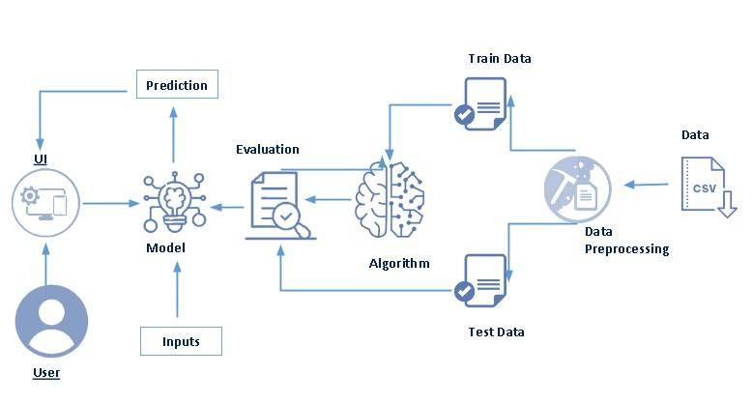 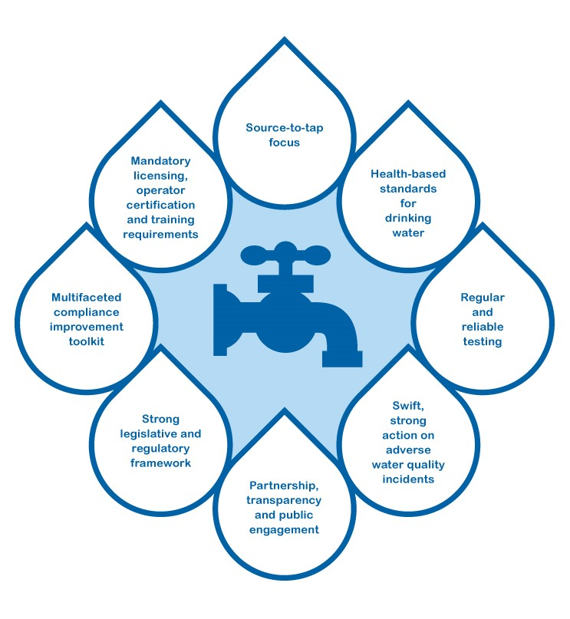

**User Stories**

Use the below template to list all the user stories for the product.

| **User Type** | **Functional Requirement (Epic)** | **User Story Number** | **User Story / Task** | **Acceptance criteria** | **Priority** | **Team Member** |
| --- | --- | --- | --- | --- | --- | --- |
| Customer (Mobile user) | Registration | USN-1 | As a user, I can register for the application by entering my email, password, and confirming my password. | I can access my account / dashboard | High | Deepa Kumari.K |
|  |  | USN-2 | As a user, I will receive confirmation email once I have registered for the application | I can receive confirmation email & click confirm | Medium | Shangavi.B |
|  |  | USN-3 | As a user, I can register for the application through Facebook | I can register & access the dashboard with Facebook Login | Medium | Kaviyanjali.P |
|  | Login | USN-4 | As a user, I can register for the application through Gmail  As a user, I can log into the application by entering email & password |  | Medium | Priya Dharshini.R |
|  | Dashboard |  |  |  |  |  |
| Customer (Web user) |  |  |  |  |  |  |
| Customer Care Executive |  |  |  |  |  |  |
| Administrator |  |  |  |  |  |  |
|  |  |  |  |  |  |  |
|  |  |  |  |  |  |  |
|  |  |  |  |  |  |  |